**YouTube Trending vs. Coronavirus**

Julianna Cole (jec56@njit.edu)

Rhea Pavithran (rp553@njit.edu)

New Jersey Institute of Technology

IS 465-002: Advanced Information Systems

Professor Xinyue Ye

April 11, 2020

**Introduction**

YouTube has become an increasingly popular source of entertainment, news, music, education, and more. Theoretically, YouTube’s trending page is updated each day with new videos that are rising quickly in popularity based on the amount of views and likes they receive. Going into this research project, we were interested in learning what types of videos become popular on YouTube. This information is valuable because it provides insights into our ever-changing culture by revealing what people are really interested in watching today. In addition to this providing insights about our media consumption as a society, this data could also be used by content creators on YouTube to give them a better idea of the type of content their viewers want to see. We were also interested in discovering if the trending page really did contain the day’s most popular videos or if it was specifically curated by YouTube instead.

Our original research questions were, “What categories are popular on YouTube, and does YouTube’s trending page really contain the most popular videos?” However, this question evolved as the coronavirus outbreak continued to get worse in the United States. We began to notice that more and more videos on the trending page were related to the coronavirus, so we shifted our focus. Our research question became, “Is there a relationship between the popularity of videos on YouTube about the coronavirus and the number of coronavirus cases in the United States?” With this question, we wanted to discover whether the increase in videos about the coronavirus was due to an increase in cases in the United States or if the situation was being sensationalized by the media. Ultimately, this information gives us valuable insights into the accuracy of our news outlets and helps us understand how people receive their news during a global state of emergency.

**Explanation of Data**

To answer our research question, we gathered data from two different sources. Our first source of data was the YouTube trending page, which is the section on YouTube that is updated regularly with the most popular videos at that given time, based on likes and number of views. Because we needed to control the data we collected, we created a schedule for ourselves in order to gather data at the same time every day. We recorded for 14 days between March 6th and 22nd at 8:00 PM every day to ensure consistency. We put this information into tables first, before counting up total ranking points based on categories and inputting that information into Excel spreadsheets so that we could track category popularity as time went on. Because our original research question was the relationship between popular YouTube categories and whether the Trending Page was accurate in terms of views and likes, we recorded the top 15 videos per day, as well as their categories, rankings, and number of views. As we progressed with our data gathering and the dangers of coronavirus became more evident, we began to notice that most of the videos on the trending page were reflecting that, with news about the virus taking over the top 15 and the most popular category becoming News and Politics. After shifting focus to relate it to hysteria surrounding the virus, we decided to compare the data we gathered to the US coronavirus statistics. We gathered this information from Worldometers, a reference website that provides real-time updates on the virus and how it is spreading throughout the world. Because our trending page data was about the United States, we looked at the US statistics for coronavirus. We looked specifically at the new daily cases as well as the total US deaths, as it helped us determine how widespread and dangerous this virus is, and whether or not it was being properly reflected in the media.

**Project Steps** (seven pages)

**Table 1: Sample Daily Recording**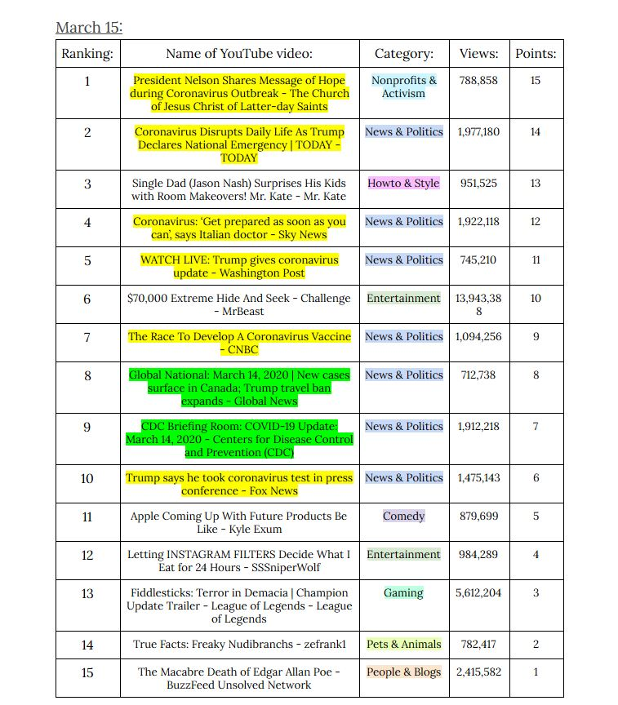

In order to record daily video rankings from March 6 to March 22, we first created this table, which records the rankings of the first fifteen videos on the YouTube Trending Page, as well as the video title, the category it was tagged under, and the number of views it got. We assigned them points based on the ranking the video got on that given day, which we then used in our Excel spreadsheet to determine the overall rankings of the categories. This is a sample table we filled out on March 15th. In this, the videos highlighted with yellow are videos with the word “coronavirus” in the title, and the videos highlighted with green are the videos still related to coronavirus without the term in the title.

**Table 2: YouTube category rankings vs. Days**

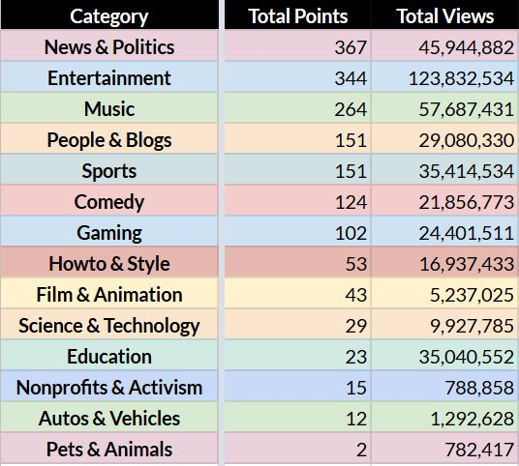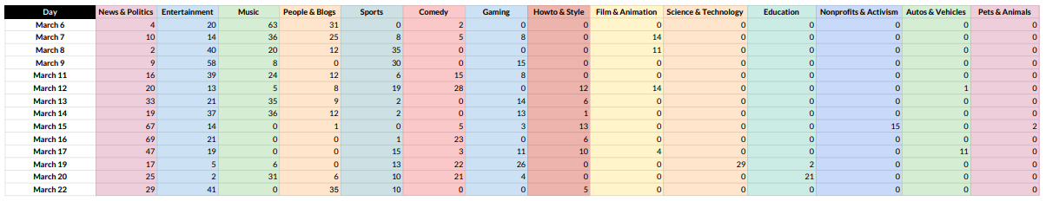

(Link: <https://docs.google.com/spreadsheets/d/1LsrxssiR_ll3x15YvUDo3TZt0FHhjZj2-hbDMNpGhIs/edit?usp=sharing>)

After tracking the YouTube Trending Page, we inputted the categories as well as their assigned rankings. In the first table, we see all the categories on the top and the dates on the side. For each day, we added the total number of rankings under a category and inputted them into the table. After collecting all our data, we created a secondary table to record the final values, which allowed us to see the final ranking of the categories in order of highest to lowest points, showing us that News and Politics ranked the highest, and Pets and Animals ranked the lowest.

**Graph 1: Most popular YouTube Trending categories & total points (bar graph)**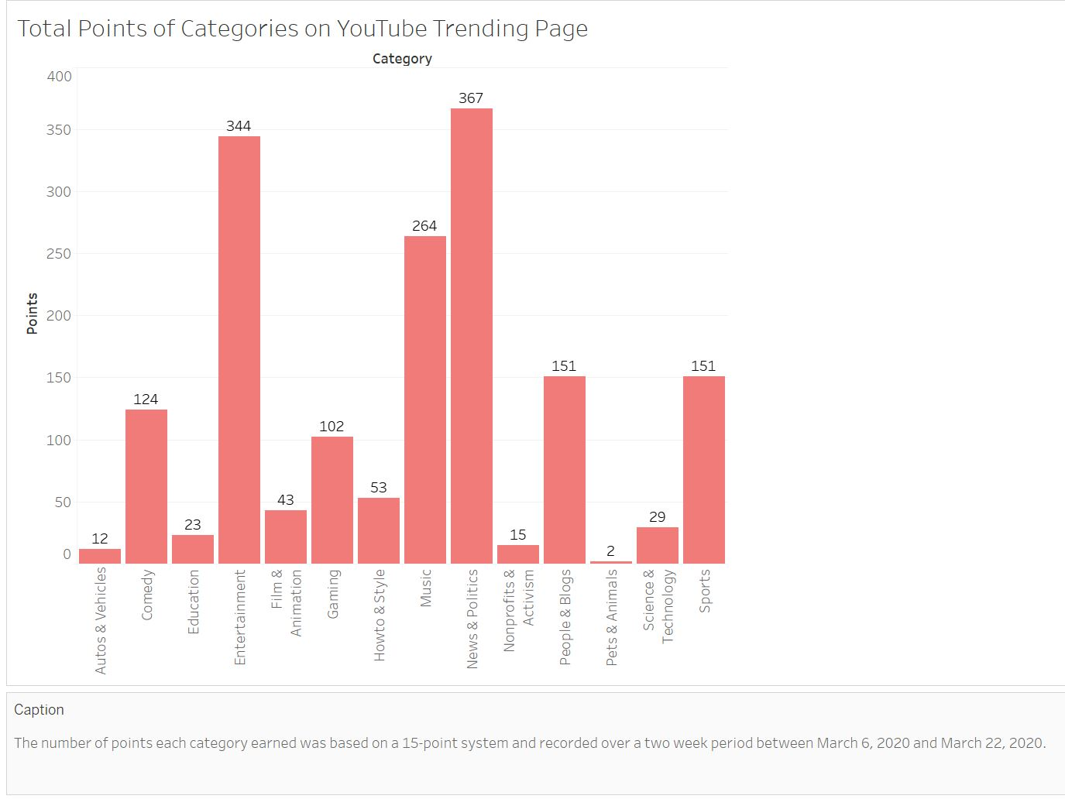

After creating our spreadsheet comparing the rankings of the categories, we then converted that into a bar graph so that we could visualize the top categories based on the total points they accumulated over the days that we recorded information. We can see that News and Politics is the highest, and Pets & Animals is the lowest.

**Graph 2: Most popular YouTube Trending categories & total points (pie chart)**

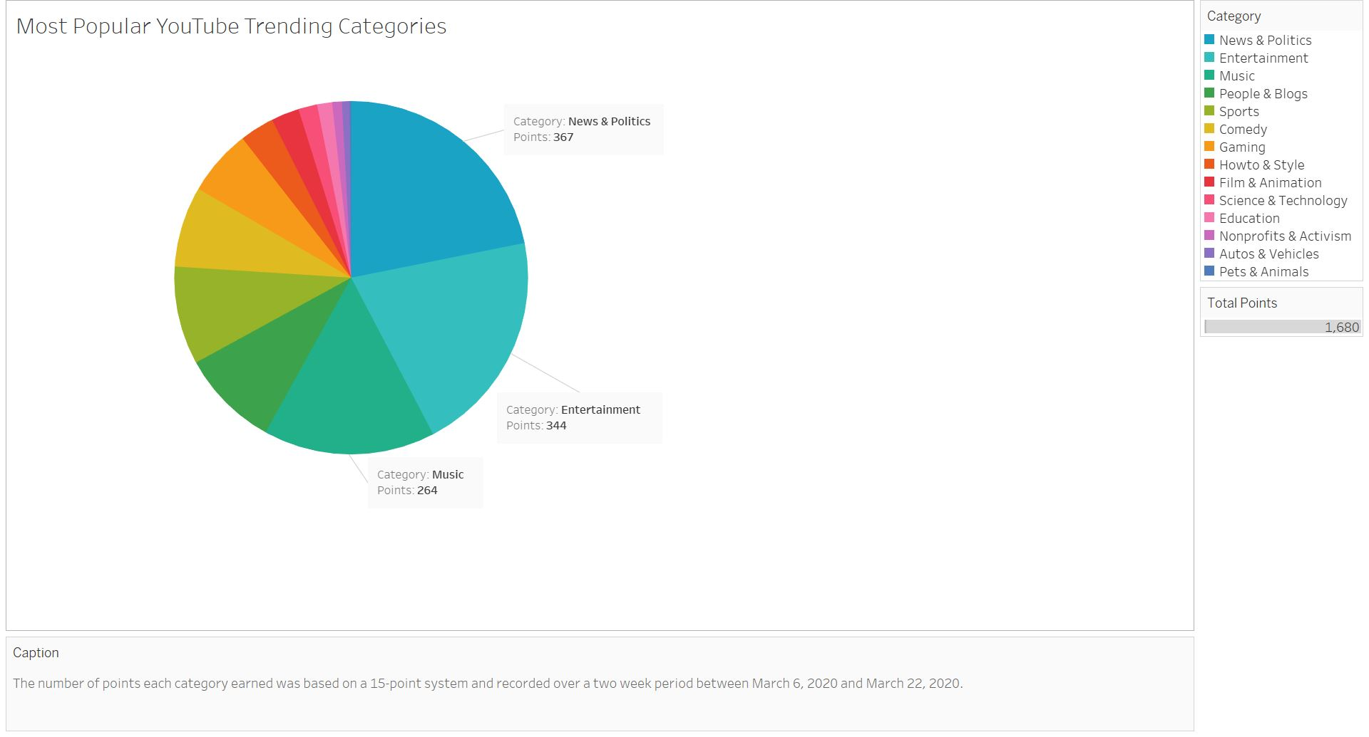

Similar to the bar graph created above, we chose to visualize the category rankings with a pie chart so we could see the percentage of categories within YouTube as well as their overall popularity over the days that we gathered information for. As we can see, because of the recent spike in coronavirus updates, News and Politics takes up the largest portion of the pie graph.

**Graph 3: Category Views v. Category Points**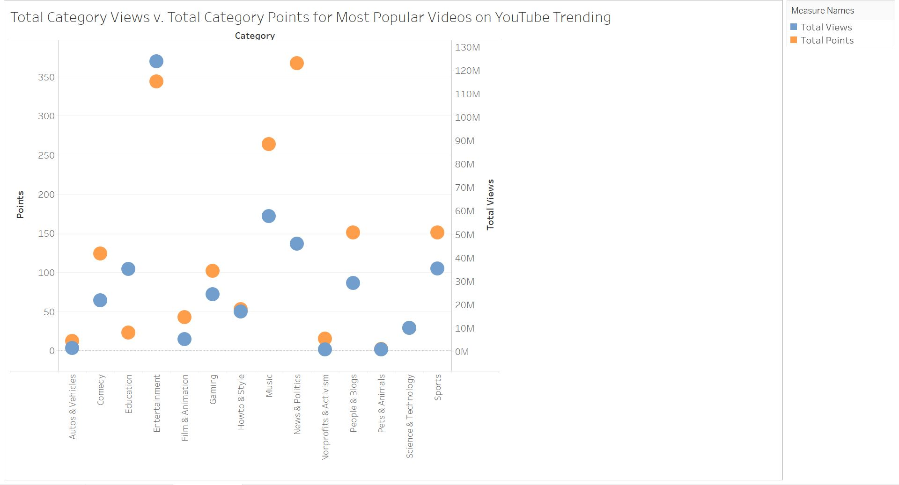

We then created a scatter plot comparing the total number of views a category received with the total number of points it received. This helped us see that although the News & Politics category was ranked #1 overall, it was not the category with the highest number of views. Entertainment was ranked #2, but has the highest number of views.

**Graph 4: Most popular YouTube Trending categories & points over time**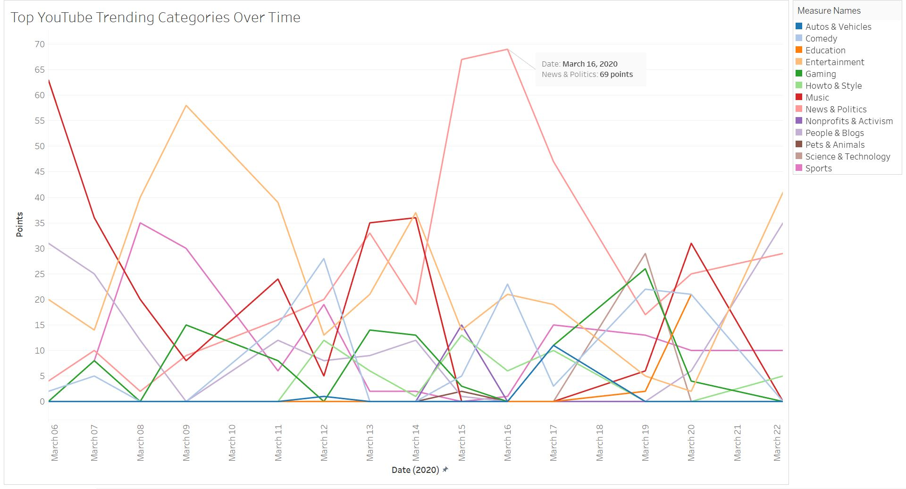

After determining the most popular categories over YouTube, we wanted to find how the popularity of these categories fluctuates over the time that we recorded data for. This helped us visualize the drastic increase of videos under the News and Politics category, and how that could align with the sudden increase of coronavirus cases.

**Graph 5 & 6: Coronavirus Statistics from Worldometers.info**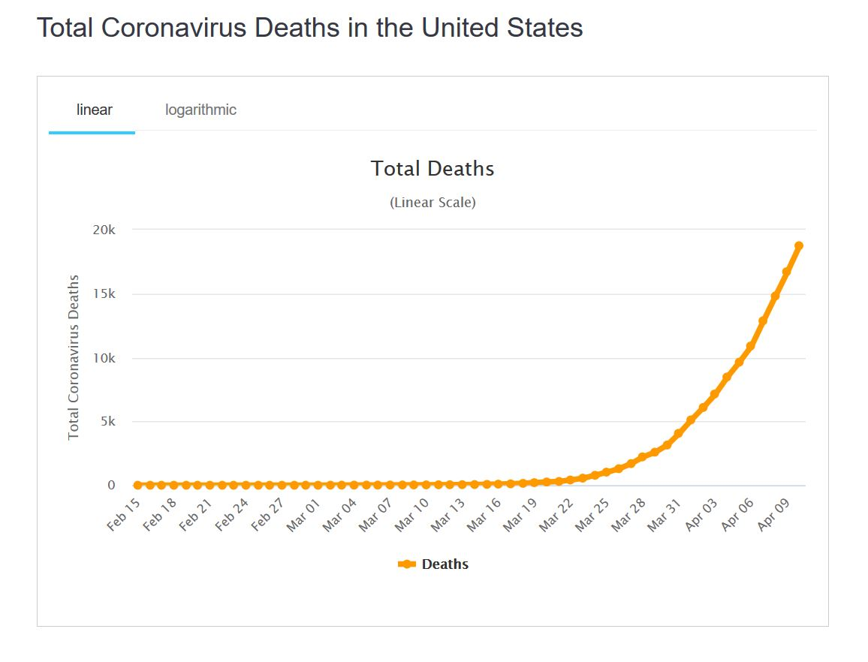

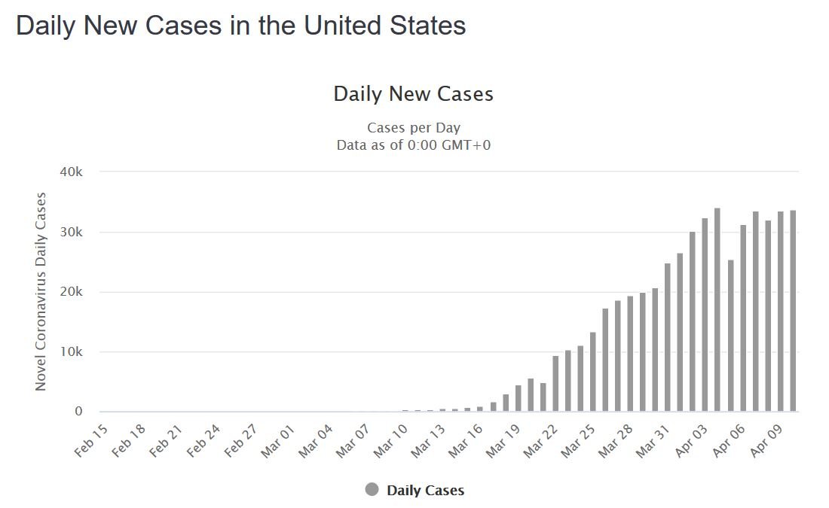

In order to determine how true the hysteria surrounding coronavirus in the media is, we had to collect data concerning the virus in the US. For this, we went to Worldometer, which gave us a plethora of statistics. From there, we had to determine what data sets we wanted to compare our research to, and we decided to use daily new cases and total deaths by day, because it tells us about how severe the cases are and how quickly it’s spreading across the United States. As we can see, the daily new cases increase after March 10, whereas the total deaths increase after March 20.

**Table 3: Coronavirus related videos vs. US Coronavirus statistics (new cases, total cases, US deaths)**

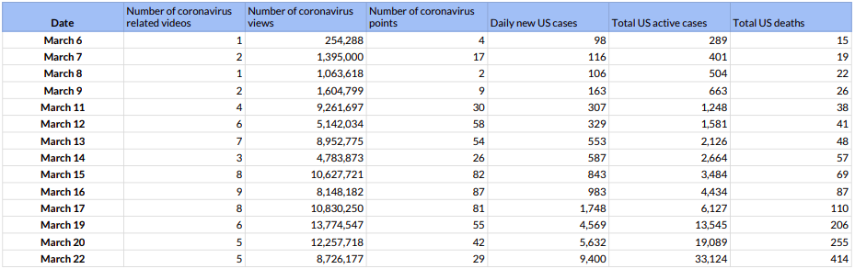

Using the information we found in our daily recordings, we calculated the number of coronavirus related videos on any given day, as well as the number of views and points earned. We compared these numbers to the graphs found on Worldometer, giving us the statistics for the daily new cases, total active cases, and total deaths in the United States from March 6 to March 22. This helped us compare the peak days of the virus versus the peak days coronavirus appeared on the trending page.

**Graph 7: Views of coronavirus related videos compared to US coronavirus case statistics over time**

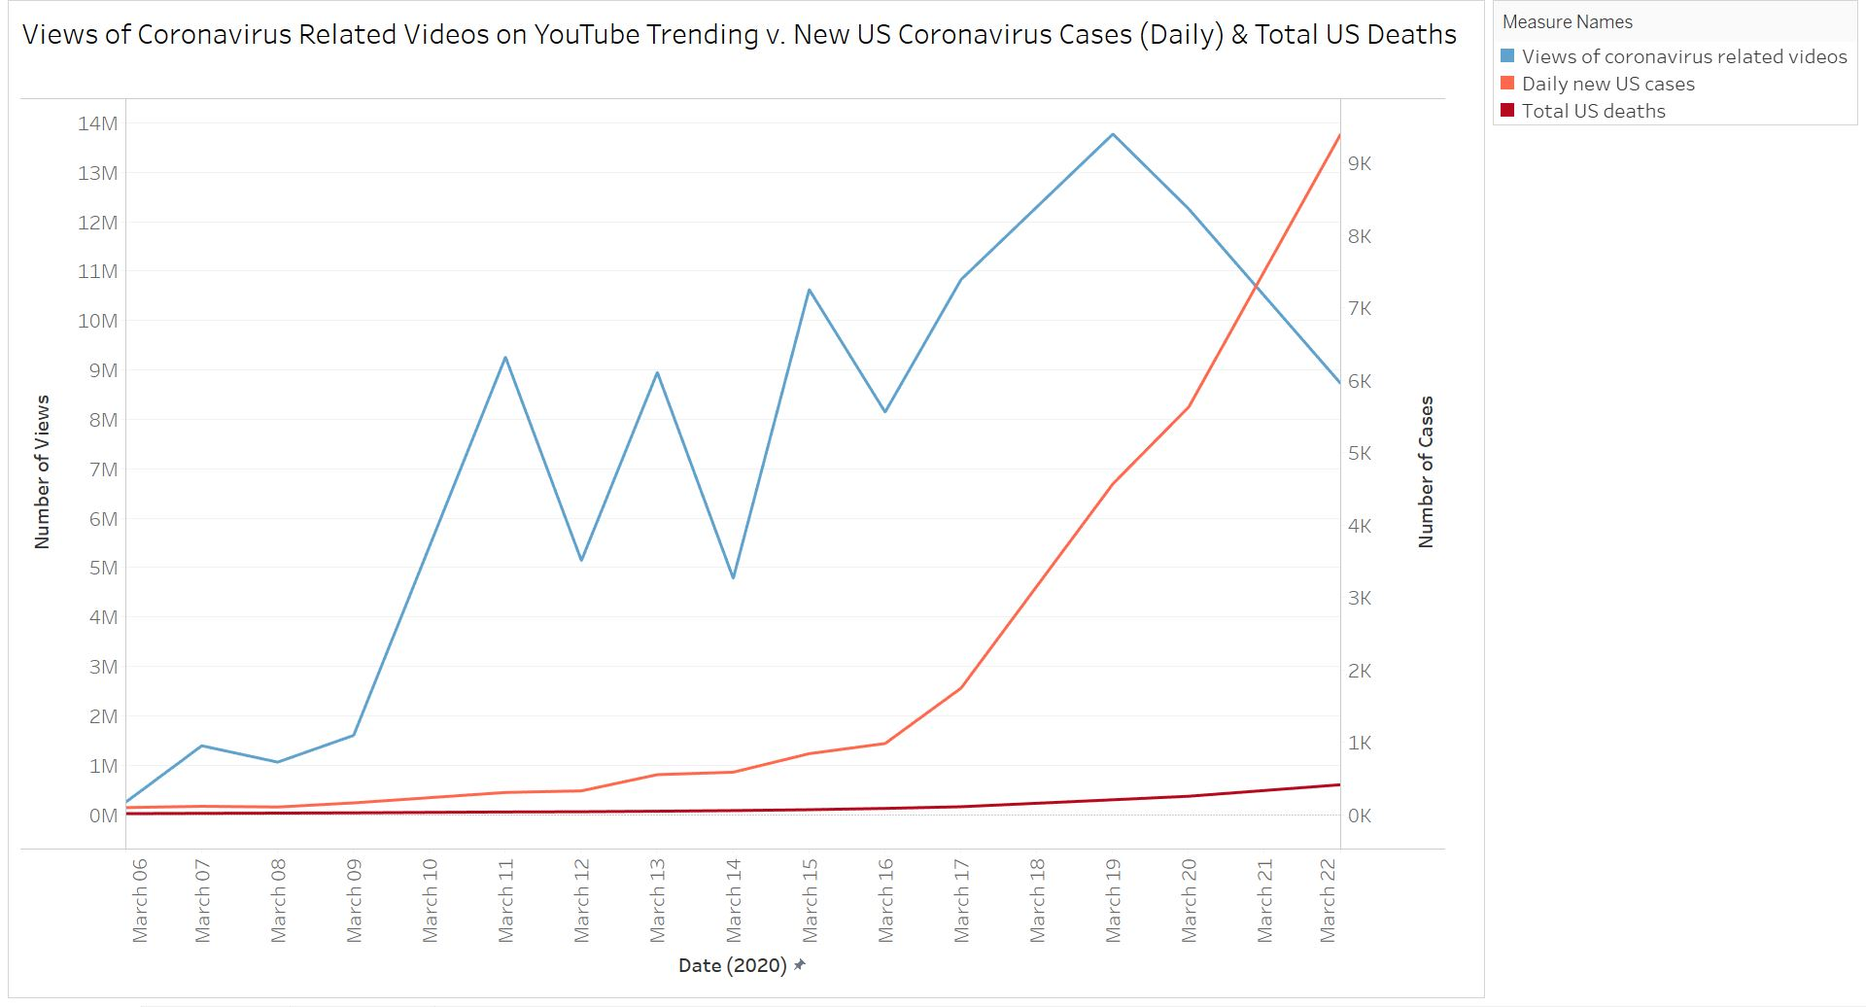

We compared our research on YouTube trending to our dataset on coronavirus in the US in three ways. The first way is by comparing the number of views the videos on coronavirus received versus the daily new US cases and total US deaths. Both new US cases and total US deaths increase, and we can see that the views of the coronavirus related videos fluctuates, but increases regardless over the time that we recorded data for.

**Graph 8: Points for coronavirus related videos compared to US coronavirus case statistics over time**

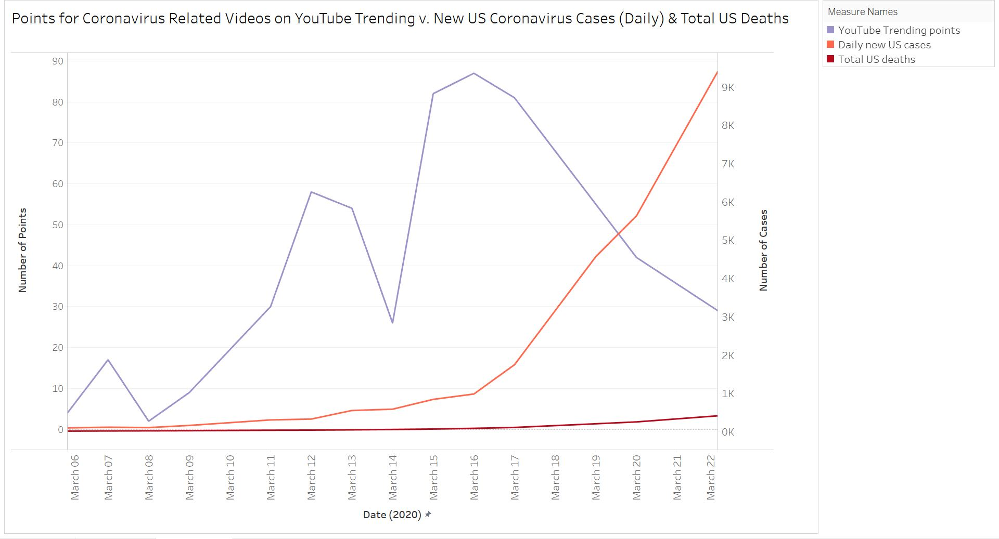

The second way we compared our research to the coronavirus statistics was by comparing the points that we found under the News and Politics category to the daily new US cases and total US deaths. This helped us see that the popularity of this category increased over the 14 days, but peaked at March 16, although the total cases and total deaths in the US were still increasing over the same period of time.

**Graph 9: Number of coronavirus related videos compared to US coronavirus case statistics**

**over time**

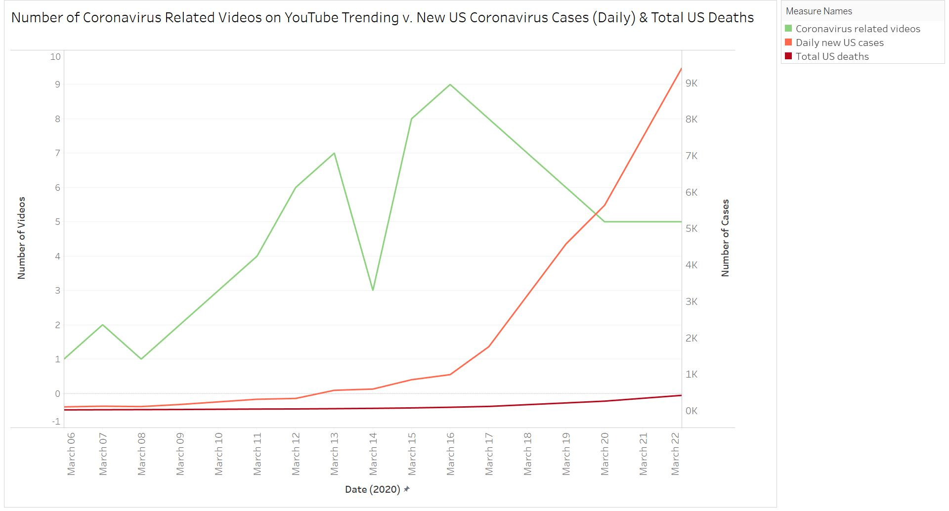

The final way that we compared our research to the dataset on coronavirus is by comparing the number of coronavirus related videos we found to the daily new US cases and total US deaths. From this, we saw that the number of coronavirus related videos again peaked at March 16, although the number of new cases and total deaths in the US were both increasing past that date.

**Results**

After analyzing our data to answer both our original research question and our new research question, we have some interesting findings. We found that during the time of recording our data, the News & Politics category earned the most points with a score of 367. The Entertainment category came in second place with a score of 344 points, and Music was third with 264 points. This indicates that there were the most videos on YouTube Trending listed under the News & Politics category.

In terms of views, however, the Entertainment category received significantly more views with 123,832,534 total views. The second most viewed category was Music with 57,687,431 total views, and the third was News & Politics with 45,944,882 total views. Initially, we thought it was odd that the Entertainment and Music categories received more views than the News & Politics category which received the most points. However, this makes sense because Entertainment and Music videos are more likely to be watched on repeat than News & Politics videos. The Entertainment category also contains a much wider variety of videos, with some related to music, news, or comedy. In addition, there is also the factor of how quickly videos are gaining likes and views. It is possible that News & Politics videos are receiving less views but at a much faster pace, which would explain their higher ranking on the trending page.

The answer to our second research question of “Does YouTube’s trending page really contain the most popular videos?” is yes. Our data does not necessarily lead us to believe that YouTube is curating which videos appear on the trending page because aside from the News & Politics category, the total number of views and points for each category are mostly in alignment. We believe the reason for this is due to the coronavirus, which we will discuss in further detail.

We took all of these findings into account as we continued onto our third research question regarding the relationship between the popularity of coronavirus related videos on YouTube and the number of cases in the United States. What we found is that these are directly related. Referring to Graph 7, Graph 8, and Graph 9, it is clear that there was a drastic increase in the amount of views, points, and number of coronavirus related videos on the trending page as the number of US cases began to grow exponentially. Most notably, we saw a huge spike in the amount of points coronavirus related videos were receiving, indicating their high ranking on the trending page. These videos had only 26 points on March 14, and in only one day, it increased to 82 points on March 15. During this time, we also saw the number of total US deaths rise from 57 to 69 and the number of US daily new cases rise from 587 to 843. It is clear that as the coronavirus started becoming a bigger threat in the United States, people were viewing more videos related to this topic.

We began to see a decrease in points and number of videos on March 16 and a decrease in views on March 19. During this time, the number of cases in the United States continued to increase rapidly. We believe that the reason for this is because more people were viewing coronavirus related videos and becoming aware of it in general during the time it started to get more serious here. By looking at the graphs, we can see that more significant increases in cases led to more views, points, and a larger number of related videos on the YouTube Trending page. Perhaps as more people become aware, there was less of a need to spread the word of the threat of the coronavirus, regardless of the number of cases. Ultimately, we found that the increase in popularity of coronavirus videos was based on statistics and was not simply a media sensation.

References

“United States Coronavirus Cases” (2020). Retrieved from

https://www.worldometers.info/coronavirus/country/us/

“YouTube Trending” (2020). Retrieved from https://www.youtube.com/feed/trending